Creating a workflow

Locate Change request Type

i) In SAP easy Access search IMGMDG

ii) Open General settings 🡪 Process Modelling 🡪 Change requests 🡪 then click on Create Chane request Type (follow Highlighted blocks below)

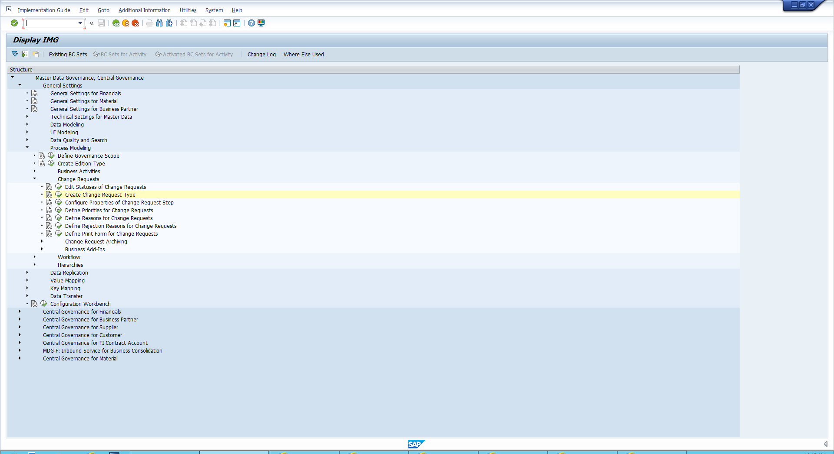

Create the CR

i) Here we will see a list of Change requests. Find change request type: MAT01.

ii) Select the Type and click Copy in the top left corner as highlighted in the image below.

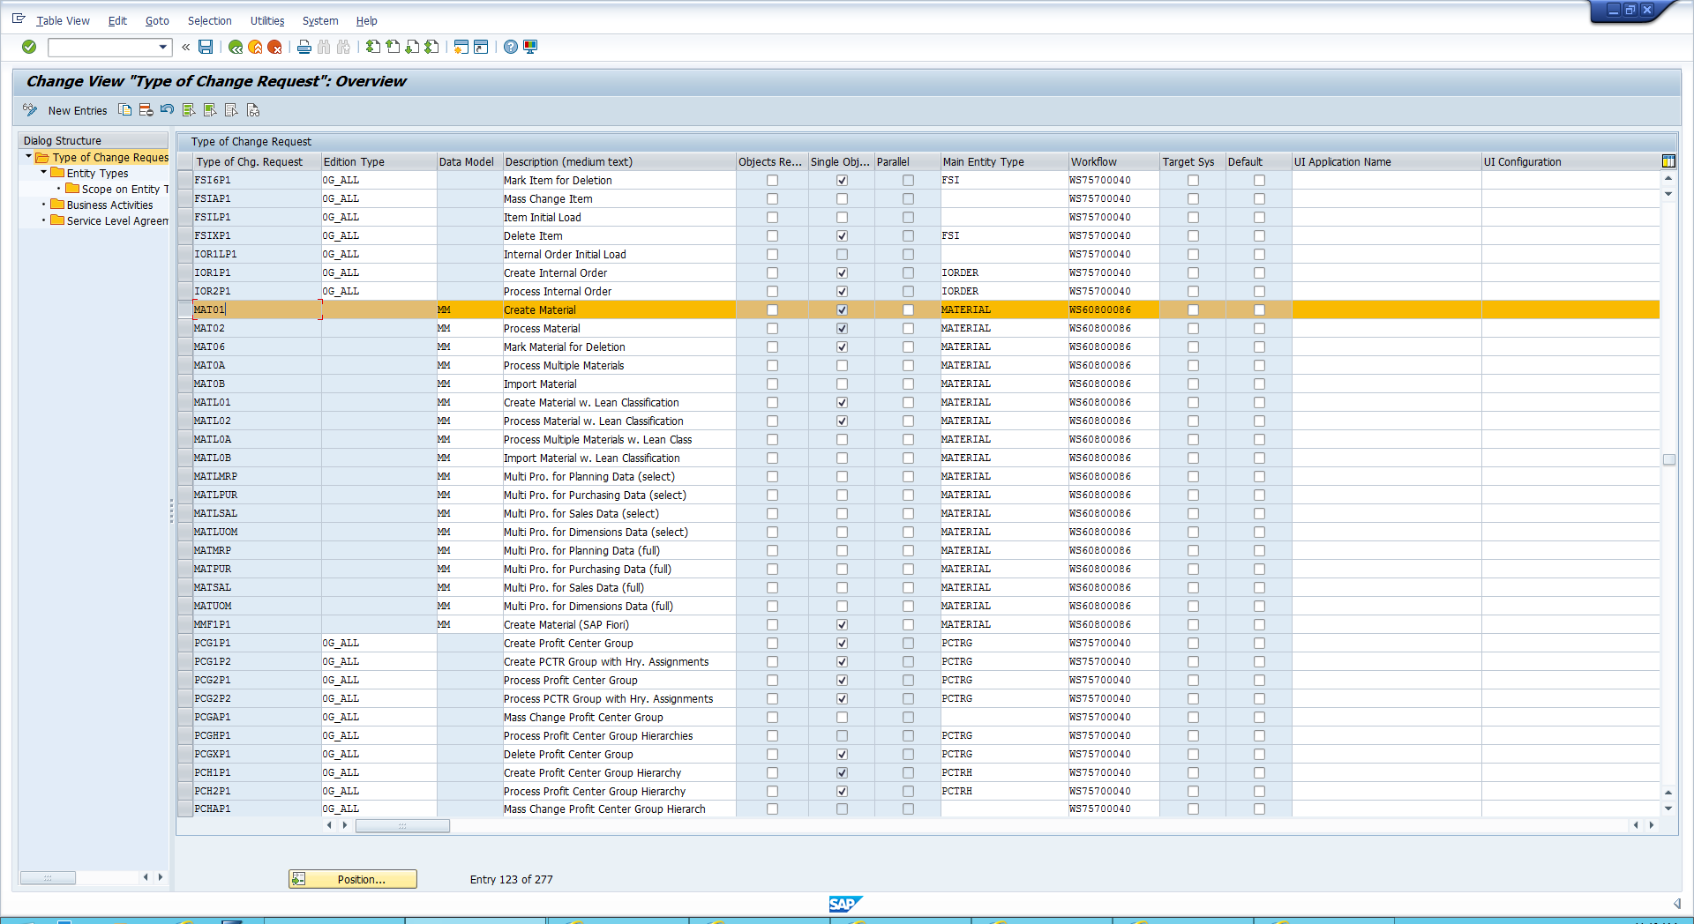

iii) Change the type of change request name eg: ZMAT01_CK. Save and click enter

Locating the workflow

i) Open General settings 🡪 Process Modelling 🡪 Workflow 🡪 Rule-Based Workflow 🡪 then click on Configure Rule-Based Workflow (follow Highlighted blocks below)

ii) Enter MAT01

iii) Open Decision Table

iv) There are three values open single Value 🡪 Click Export to Excel 🡪 Do the same for the other two tables

Inputting tables to your Change Request

i) Open General settings 🡪 Process Modelling 🡪 Workflow 🡪 Rule-Based Workflow 🡪 then click on Configure Rule-Based Workflow (follow Highlighted blocks below)

ii) Enter your change request name eg: ZMAT01_CK

iii) Open the decision table 🡪 Click Edit 🡪 Click Additional actions 🡪 Import from Excel (As shown below)

iv) Do this again for the other two tables importing the associated excel File

